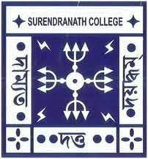
SURENDRANATH COLLEGE
24/ 2 M.G ROAD KOLKATA – 700009
DEPARTMENT OF PSYCHOLOGY
ACADEMIC CALENDAR 2022-2023
ACADEMIC SESSION: AUGUST TO JULY
EVENTS | DATES
- Orientation of newly admitted B. A/ B.Sc First Semester Students  - Death anniversary of Sir Surendranath Bannerjee.  - Independence Day celebration, Flag hoisting at college campus.  - Teachers’ Day celebration.  - Birthday of Sir Surendranath Bannerjee  - Calcutta University Foundation Day  - Republic Day Celebration, flag hoisting at college campus.  - Annual Sports Day  - National Science Day Celebration  - International Women’s Day Celebration  - Rabindra Jayanti Celebration  - World Yoga Day Celebration | 04.08.2022  06.08.2022  15.08.2022  05.05.2022  10.11.2022  24.01.2023  26.01.2023  Last week of February  28.02.2023  08.03.2023  09.05.2023  21.06.2023

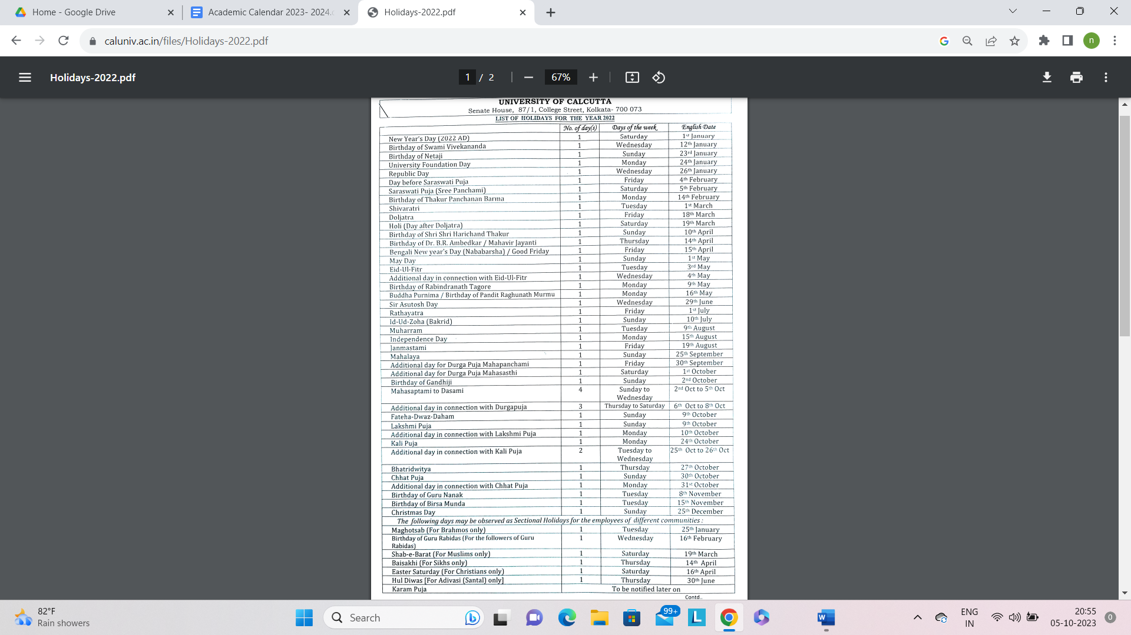

AUGUST 2022
- Commencement of Semester 1 Hons classes (CBCS Syllabus).
- Semester 2 Hons Examination started.
- Semester 5 classes started. (Theory+ Practical)
- Semester 6 results were published.
- Mentoring session started for semester 1.
SEPTEMBER 2022
- Semester 1 & 5 Hons classes continued (Theory + Practical)
- Periodic assessment of Semester 1 was done by Viva voce. Questions were framed by following Bloom’s Taxonomy.
- Commencement of Semester 3 Hons classes (Theory + Practical)
- Semester 4 Hons results were published..
- Mentoring session For Semester 1, 3, & 5 continued.
October 2022
- Puja Vacation started.
- Semester 2 results were published.
NOVEMBER 2022
- Semester 1, 3 & 5 Hons classes continued (Theory + Practical)
- Periodic assessment of Semester 3 & 5 were done by PPT presentation. Assessment was done following Bloom’s Taxonomy.
- Mentoring session For Semester 1, 3, & 5 continued.
December 2022
- Semester 1 & 3 Hons classes continued (Theory + Practical)
- Internal assessment of Semester 5.
- Remedial classes for Semester 5.
- Mentoring session For Semester 1, 3, & 5 continued.
- Preparation for NAAC peer team visit.

JANUARY 2023
- Internal assessment of Semester 1 & 3
- Semester 5 Examination started.
- Remedial classes for Semester 1 & 3.
- Mentoring session For Semester 1 & 3 continued.
FEBRUARY 2023
- Semester 6 class started. (Theory+ Practical)
- Semester 1 & 3 Examination started.
- Publication of Semester 5 result.

MARCH 2023
- Semester 2 & 4 class started. (Theory+ Practical)
- Semester 6 classes continued. (Theory + Practical)
- Publication of Semester 1 & 3 results.
- Mentoring session For Semester 2, 4, & 6 continued.

APRIL 2023
- Semester 2, 4 & 6 classes continued. (Theory + Practical)
- Mentoring session For Semester 2, 4, & 6 continued.
- Field trip for Semester 6 was arranged.
- Periodic assessment of Semester 2, 4 & 6 were done by PPT presentation. Assessment was done following Bloom’s Taxonomy.

MAY 2023
- Internal assessment of Semester 6
- Semester 2 & 4 classes continued. (Theory + Practical)
- Remedial classes for Semester 6.
- Mentoring session For Semester 2, 4, & 6 continued
- Farewell Program was arranged for Semester 6.
- Summer Recess started
JUNE 2023
- Internal assessment of Semester 2 &4
- Remedial classes for Semester 2, 4, & 6.
- Mentoring session For Semester 2, 4, & 6 continued
- Summer recess continued
JULY 2023
- Remedial classes for Semester 2, & 4.
- Mentoring session For Semester 2 & 4 continued.
- Semester 6 Examination started.
- An International Workshop for students was arranged.

