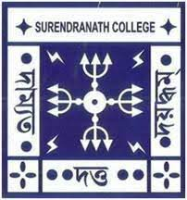
SURENDRANATH COLLEGE
24/ 2 M.G ROAD KOLKATA – 700009
DEPARTMENT OF PSYCHOLOGY
ACADEMIC CALENDAR 2023 – 2024
ACADEMIC SESSION: AUGUST TO JULY
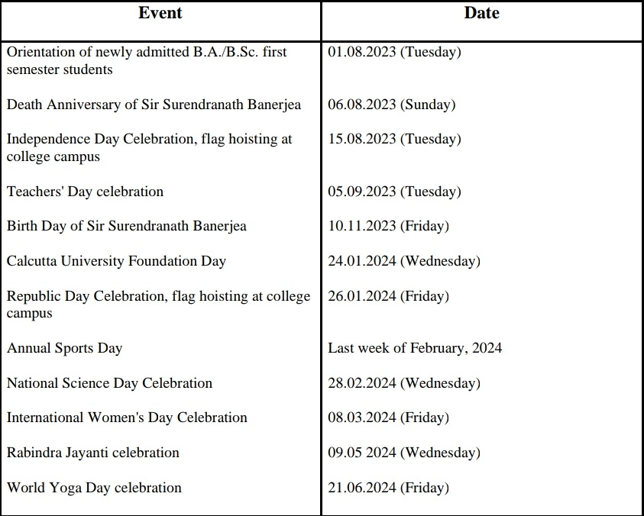

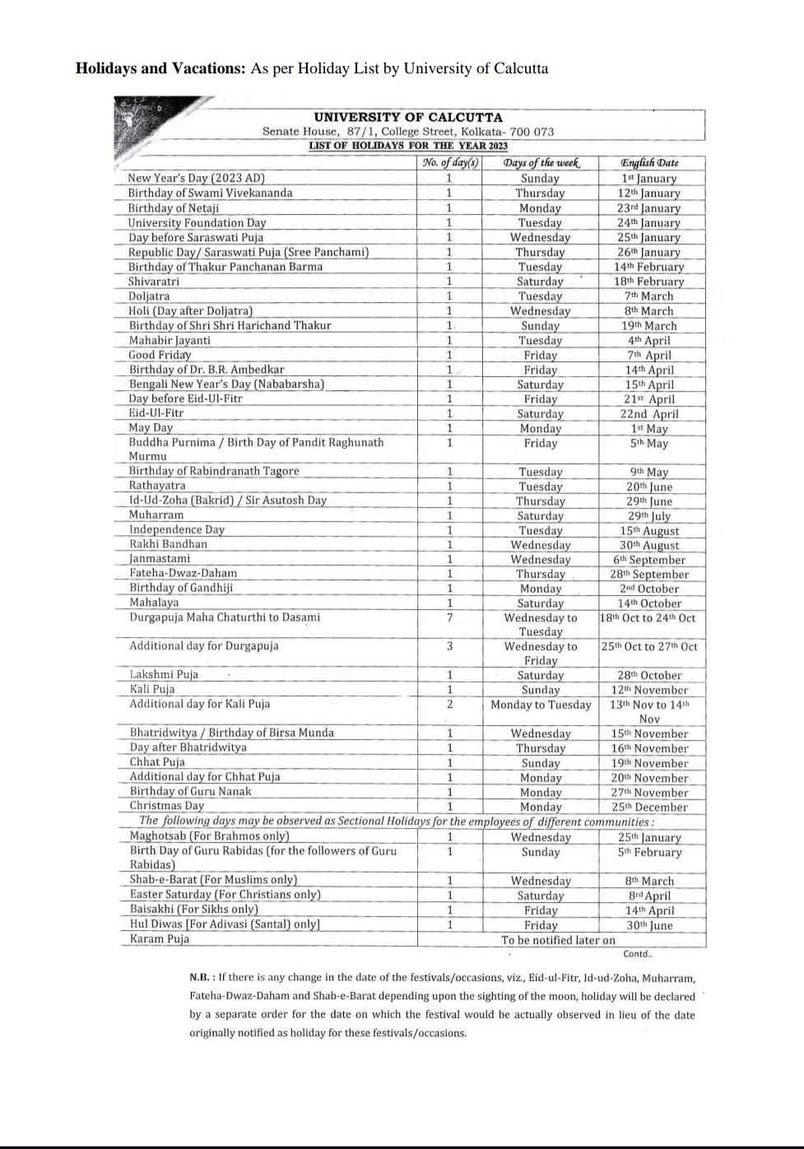

AUGUST 2023
- Commencement of Semester 1 Hons classes (NEP Syllabus).
- Semester 4 Hons Theory & Practical Examination.
- Remedial (For Slow Learners, following Bloom’s Taxonomy) & Mentoring Classes for Semester 2 students were continued.
- Mentoring session started for semester 1.
SEPTEMBER 2023
- Semester 1 Hons classes continued (Theory + Practical)
- Periodic assessment of Semester 1 was done by Viva voce. Questions were framed by following Bloom’s Taxonomy.
- Commencement of Semester 5 Hons classes (Theory + Practical)
- Semester 2 Hons Theory & Practical Examination.
- Mentoring session For Semester 1 & Semester 5 continued.
- Semester 4 result declared.
OCTOBER 2023
- Commencement of Semester 3 Hons classes (Theory + Practical)
- Semester 1 & 5 Hons classes continued (Theory + Practical)
- Puja Vacation
NOVEMBER 2023
- College reopens after puja vacation.
- Semester 1 & 3, 5 Hons classes continued (Theory + Practical)
- Tentative Publication of Semester 2 result.
- PTM for Semester 1
DECEMBER 2023
- Internal Examination of Semester 5.
- Periodic Assessment of Semester 1 will be done. (Class Test of 20 marks)
- Semester 1 & 3 Hons classes will be continued (Theory + Practical)
- Remedial classes will be arranged for Semester 5 & 1

JANUARY 2024
- Tentative Semester 5 Examination
- Tentative of Semester 1 Examination.
- Internal assessment will be arranged for Semester 3.

- Remedial classes will be arranged for Semester 3.

FEBRUARY 2024
- Tentative of Semester 3 Examination
- Commencement of Semester 2 & 6 Classes. (Theory + Practical)
- Tentative publication of result of Semester 1 & 5.

MARCH 2024
- Semester 2, 4, 6 classes will be continued. (Theory + Practical)
- Tentative publication of result of Semester 3.
- Periodic assessment for Semester 6 will be arranged. (PPT Presentation) Evaluation will be done following Bloom’s Taxonomy.

APRIL 2024
- Semester 2, 4, 6 classes will be continued. (Theory + Practical)
- Periodic assessment for Semester 2 &4 will be arranged. (PPT Presentation) Evaluation will be done following Bloom’s Taxonomy
- Departmental field trip will be arranged for Semester 6.

MAY 2023
- Internal Examination of Semester 6.
- Periodic Assessment of Semester 2 will be done. (Class Test of 20 marks)
- Semester 4 Hons classes will be continued (Theory + Practical)
- Remedial classes will be arranged for Semester 6 & 2

JUNE 2024
- Tentative Semester 6 Examination
- Tentative of Semester 2 Examination.
- Internal assessment will be arranged for Semester 4.

- Remedial classes will be arranged for Semester 4.

JULY 2024
- Tentative Semester 4 Examination
- Tentative Commencement of Semester 3(Theory + Practical)
- Tentative of publication of result of Semester 2 & 6..

